Final Project Draft Report

Edy Morales

Najia Sultana

Intro

Opening up a pizza business in the City of New York can be very competitive. Our business has to keep up with our competition in order to stay successful for the coming years. New York is well known for their pizza, so we have to keep up to that standard. That’s why our business will be offering many types of options from whole pies to single slices. As well as offering a variety of toppings to the pizza. We have to analyze all that data we start off with and start making decisions to help increase the success of our business.

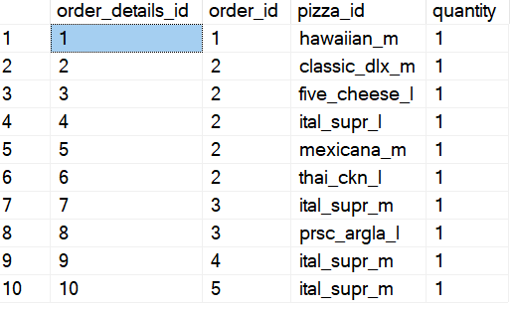

Using some of the data provided from sql, you can see the popular pizza options. The popular ones would stay on the menu while the least ordered toppings would get removed in order to save costs. The cost of a pizza would depend on the toppings. Keeping in mind our competitors pricing as well that will determine the cost of a certain pie.

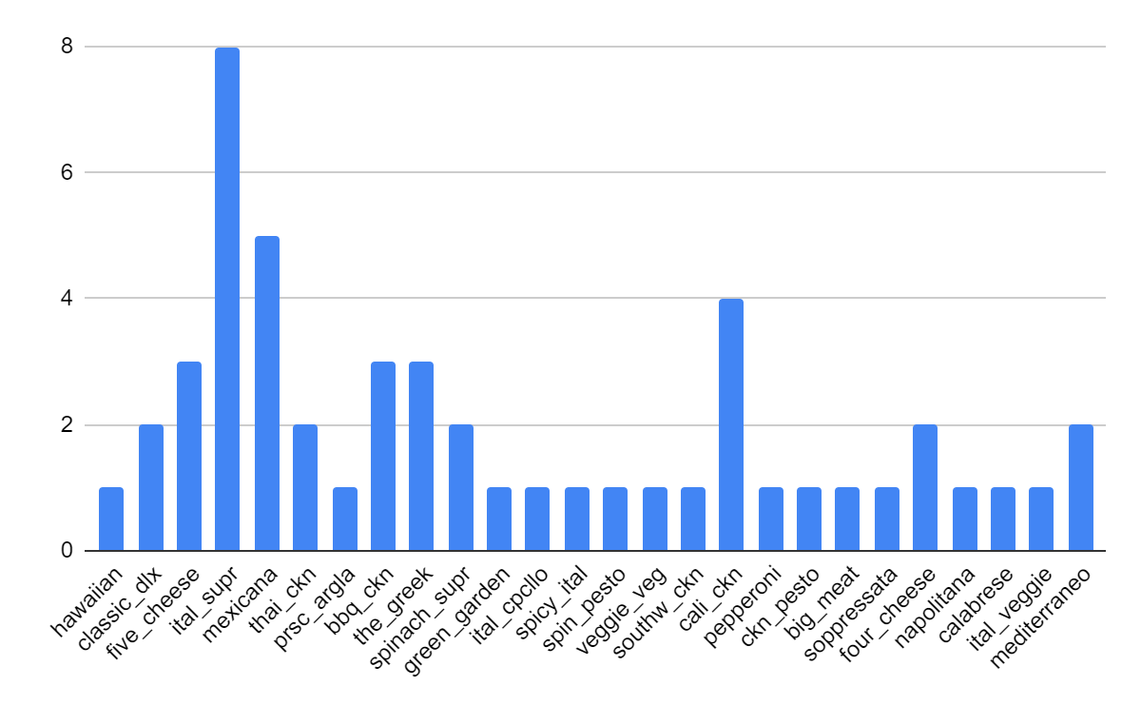

Using excel, this data was pulled from SQL.

select pizza_id

from dbo.pizza_order_details

Using this command on sql would only provide the types of pizza people have ordered from the restaurant. From the data, the first 50 orders were taken to excel. The first 50 orders, we can see what pizza types are going to be more popular than others. Although having more data would result in a more accurate representation of popular pizza types, this would give us a glimpse of what’s to come in the future.

Depending on the size and type of pizza people order. The prices will vary because of needed ingredients but also keeping in mind that the prices have to be competitive with other businesses.

In SQL, the data provided, we can see some set prices based on type of pizza and size using the command:

select pizza_id, size, price

from dbo.pizza_prices

This pizza restaurant would also have to think about other expenses to compete with other businesses such as offering wings, beef patties, chicken rolls. In this project, there won’t be any single slices being offered unfortunately.